PRD: SharePoint Connector V1 Final Release State

1. Project Details
Project / Feature Name: SharePoint Connector GA
Document Owner: Loren
Dev Leading: Guy, Artem
Last Updated: Feb. 21st, 2026
Status: Final release state - QA validation and Updated UI Images Required
Referenced Components:
- Purview Component PR
- PAR Project PR
Future Versions Record: Link

2. Connector Objectives

SpecterX integrates directly into SharePoint workflows, allowing users to provision secure external access without relying on native guest links or distributing unmanaged file copies. Files remain stored within the organization’s SharePoint tenant, while SpecterX governs access, visibility, and enforcement according to organizational policy and data sensitivity. By implementing the SpecterX Sharepoint Connector, organizations can enable external collaboration confidently, while ensuring shared data remains protected and controlled throughout its lifecycle.

Table of Contents
1. Project Details 1
2. Connector Objectives 1
Table of Contents 2
3. Operating Logic 3
3.1 V1 Scope File Sharing Only 4
3.2 Architecture Logic – How SpecterX Governs SharePoint Files 4
Two-Stage Share Model: 4
Behavior After PAR Approval 5
Behavior Upon Recipient Access 5
PAR Block Behavior for SharePoint 5
Inbound Files (Send-Back + Workspaces) - Out of Scope 5
3.2 Connector Logic – What the SharePoint Connector Does 6
Exposure of the SpecterX Share Action 6
Collecting File Context When the User Initiates a Share 6
Launching the SpecterX Workflow 6
Backend Changes per Platform Rule Evaluation 7
Boundaries of Connector Responsibility 7
3.3 Deployment Logic – Where Users Can See and Use the Connector 7
Site-Level Deployment Determines Availability 7
SharePoint Determines Who Can Use It 7
Deployment Does Not Assign Licensing 8
Supported Deployment Patterns (Logical Combinations) 8
3.4 Deployment Nuances (Logic Only) 8
3.5 Purview Classification Integration (Logic Only) 8
3.6 File Content Changes Syncing Logic 9
3.7 How the Sharepoint Connector Presents to Users 9
User Experience 9
Share Drawer Opening Appearances 10
3.8 Reference Indicators Published within Sharepoint Tenant 11
4. Edge Cases – Concise Logic for Review 12
4.1 Reference File Deleted or Moved in SharePoint 12
4.2 Multiple Collaborators Sharing the Same SharePoint File 12
4.3 Same User Shares the Same File Multiple Times 13
4.4 SharePoint Permissions Change After a Share 13
4.5 Purview Classification Changes Over Time 13
5. Limitations & Constraints 14
5.1 Mobile and Sync Clients 14
5.2 Customer Implemented Encrypted File Transformation Conflict with SpecterX - Purview Limitation Intersection 14
Expected Behavior When This Conflict Occurs 15
5.3 Folder Sharing & Synced Changes are not Supported 15
6. Technical Architecture & Implementation 16
6.1 High-Level Architecture 16
Core Components 16
6.2 Authentication & Token Management (The "Deferred Fetch" Mechanism) 16
6.2.1 Token Seeding Flow 16
6.2.2 Token Lifecycle 17
Update 17
6.3 Data Flow & File Lifecycle 17
6.3.1 Outbound Sharing (Metadata Only) 17
6.3.2 Recipient Access (Just-in-Time Fetch) 18
6.4 Visual Indicators (Visual Markers) 18
6.5 Microsoft Purview Integration 19
6.6 Security & Permissions 19
6.7 Key API Interface Summary 20
7. Development Kit 20
SharePoint Testing Environment 20
User Login 20
Admin Login 20
Installing / Updating the App 21
Repos 22
8. Future Versions Plans at Release 23

3. Operating Logic
The SharePoint Connector integrates SharePoint’s in-place file storage model with the SpecterX governance model. It does this through a coordinated two-layer design:
- Architecture Layer – Defines how SpecterX governs SharePoint content:
reference-file handling, PAR evaluation, protected-copy creation, and inbound storage.
- Connector (App) Layer – Provides the user entry point inside SharePoint, collects minimal context for PAR, and reflects SpecterX decisions back into SharePoint.
Together, these layers allow SharePoint files to remain fully in-place and unmodified while SpecterX manages all governance, protection, and external-sharing controls. Deployment defines where users can access SpecterX; SpecterX policy defines what happens once they do.

3.1 V1 Scope File Sharing Only
The V1 Scope of the Sharepoint Connector supports the sharing of singular files or multiple individual files selected and shared together, but does not support the sharing of folders.

The Sharepoint Connector supports the sharing of files directly from the users Sharepoint library but doesn't support the receival of files directly to the Sharepoint library.

- If recipients leverage the “Share Files Back” feature of the recipient page, files uploaded by recipients are stored within the tenant configured dedicated storage integrated to SpecterX.

3.2 Architecture Logic – How SpecterX Governs SharePoint Files
The architecture is built around the principle that SharePoint stores the reference file, and SpecterX produces the governed, protected copy at the time of recipient access.

Two-Stage Share Model:
Stage 1 – Authorization & Registration
- The connector sends file metadata to PAR.
- If allowed, SpecterX generates the access link and records the file in My Files as “Uploaded to SPX.”
- The SharePoint file remains untouched and unprotected.
Stage 2 – Recipient Access & Protection
- When a permitted recipient authenticates, SpecterX retrieves the reference file from SharePoint.
- SpecterX creates a protected copy, applies all policy controls, and delivers it.
- The SharePoint version remains unmodified.

Behavior After PAR Approval
- Access link created according to governing policy.
- The file is registered in My Files with governing policy and recipient list.
- The SharePoint file remains unprotected and unchanged.

Behavior Upon Recipient Access
- SpecterX copies the reference file out of SharePoint.
- SpecterX applies protections (encryption, watermarking, usage restrictions).
- The governed version is delivered to the authenticated recipient.
- The SharePoint file remains the reference version.

PAR Block Behavior for SharePoint
- Block messages appear in real time in the SpecterX share workflow.
- No link is created, no recipients added, and nothing appears in My Files.
- Real-time surfacing aligns with Workspace behavior and differs from email-based block notifications used by other connectors.

Inbound Files (Send-Back + Workspaces) - Out of Scope
Note: Current implementation supports outbound flows only.
Inbound content never writes to the customer’s SharePoint environment.
- All inbound files use SpecterX dedicated storage, which may be backed by SharePoint or another supported backend.
- Outbound SharePoint content uses SharePoint as a reference location; inbound content follows SpecterX’s controlled-storage model only.

3.2 Connector Logic – What the SharePoint Connector Does
The SharePoint Connector is an SPFx extension inside the customer’s SharePoint environment. It does not evaluate policy, protect content, or manage files; it exposes SpecterX, captures minimal context, and reflects SpecterX outcomes.

Exposure of the SpecterX Share Action
When deployed to a site:
- The Share via SpecterX command is available across the entire site.
- Visibility is governed by SharePoint permissions and optional audience targeting.
- The connector does not use file classification, policy rules, or content properties to determine visibility.

Collecting File Context When the User Initiates a Share
The connector gathers:
- File identifier and path
- Site/library context
- Initiating user identity
It never inspects file contents. The connector seeds the user's Graph API access token to the SpecterX Backend to enable deferred file fetching and metadata retrieval.
If Purview is integrated (see Section 6):
- The SpecterX Backend retrieves the file’s Purview sensitivity label metadata using the seeded user token and forwards it to PAR.

Launching the SpecterX Workflow
- The connector opens the SpecterX share interface and prompts the user for recipient detail, policy and completion of the share.
- Post Share message displays the share as Sent - although backend share evaluation may cancel or alter the share operation.
- If the share window is closed before the share is completed, the file(s) of the initiated share are not uploaded to the user's My Files instance.

Backend Changes per Platform Rule Evaluation
If the share triggered Action by Platform Rules, the sender is notified via mail notification. See Platform Governance Rules PRD section here.
- As per PAR logic, files shared and blocked are still updated to the user’s My Files instance and therefore Sharepoint file reference indicators remain published in the UI even if files are blocked from all recipients.

Boundaries of Connector Responsibility
The connector does not:
- Apply or enforce policy
- Create or store protected copies
- Generate access links
- Interpret Purview labels
- Inspect or modify the reference file
- Manage inbound file handling

3.3 Deployment Logic – Where Users Can See and Use the Connector
Deployment defines availability, not governance.

Site-Level Deployment Determines Availability
- When deployed to a site, the connector is available across the entire site.
- Deployment cannot be scoped to libraries, folders, or individual files.
If not deployed to a site, the connector does not appear there.

SharePoint Determines Who Can Use It
User visibility is controlled entirely by:
- SharePoint permissions (e.g., Contribute)
- Optional SharePoint audience targeting / group membership
Classification, PAR rules, or policy attributes do not influence visibility.

Deployment Does Not Assign Licensing
- Deployment makes the command available but does not assign SpecterX licenses.
- Users are provisioned automatically when they perform their first SpecterX share.

Supported Deployment Patterns (Logical Combinations)
- All Users + All Sites
- All Users + Some Sites
- Some Users + All Sites
- Some Users + Some Sites
These four combinations represent the full deployment model.
Operational steps belong in the Deployment Guide.

3.4 Deployment Nuances (Logic Only)
Deployment behavior is strictly site-wide and SharePoint-defined:
- Once deployed to a site, the connector appears everywhere the user has permission.
- Visibility cannot be narrowed to specific files, folders, or content types.
- Deployment does not determine whether a share is allowed; PAR and SpecterX policy do.
- Deployment never writes or modifies SharePoint content.
All configuration mechanics are covered in the Deployment Guide, not here.

3.5 Purview Classification Integration (Logic Only)
If the customer has integrated SpecterX with Microsoft Purview:
- The SpecterX Backend retrieves the file’s Purview sensitivity label metadata using the seeded user token.
- The Backend forwards this metadata to PAR with the file identifiers.
- The connector does not interpret or enforce classification rules locally.
- Classification does not affect visibility of the connector command; SharePoint permissions do.
- SpecterX policy determines how classification influences the sharing decision.
All implementation details (permissions, API usage, metadata formats) belong in the Purview Integration Guide. (See Technical Task 8 and separate Purview Integration Doc: PRD: Purview Sensitivity Labels Ingestion)

3.6 File Content Changes Syncing Logic
The Share-in-place model of the Sharepoint Connector architecture, supports file changes made to files within the governing organization’s Sharepoint instance, to be reflected in recipient access copies.
- Changes made to the file copy are reflected as soon as changes are saved to the reference copy.
- Post share changes will not be reflected in previously downloaded file copies, even if downloaded copies are protected.
- Changes made by recipients will not be reflected back to the reference copy in the governing organization’s Sharepoint Library.

3.7 How the Sharepoint Connector Presents to Users

User Experience
Once deployed, users within the authorized sites will see new SpecterX share options integrated directly into the SharePoint interface.
Share With SpecterX Options
- Right-Click Context Menu
Users can right-click on any accessible file or folder and choose “Open with → SpecterX” to initiate a secure share.
- Share Menu in Toolbar
Users can also select one or multiple files/folders and click the “Share with SpecterX” button appearing in SharePoint’s upper action bar.
This supports multi-file and folder batch sharing.
Share Options are presented as shown in Screenshot below: (replace with actual GA copy)
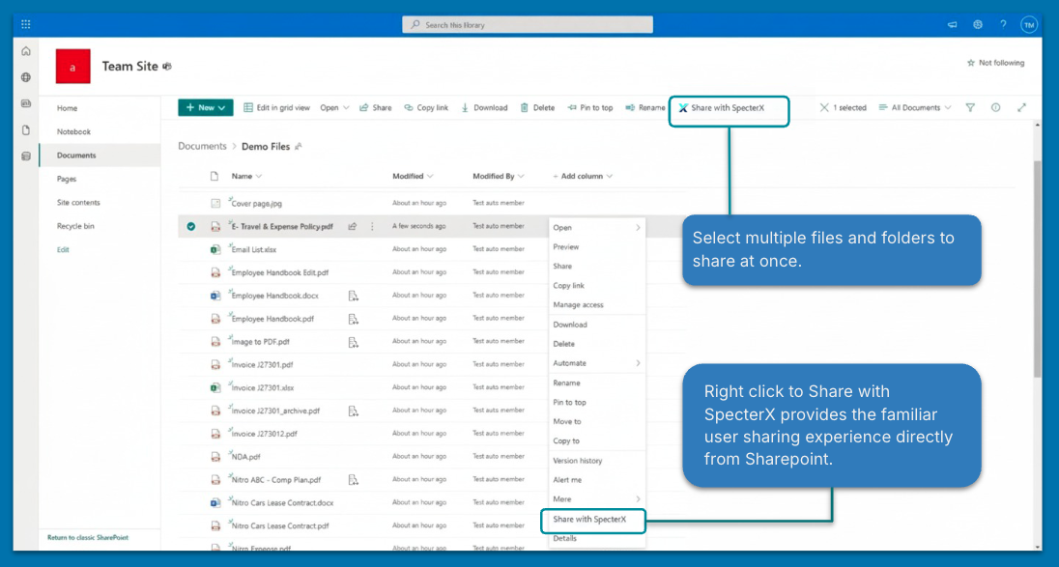

Share Drawer Opening Appearances
After selection of “Share with SpecterX”, the Share Drawer opens for the share to be completed.
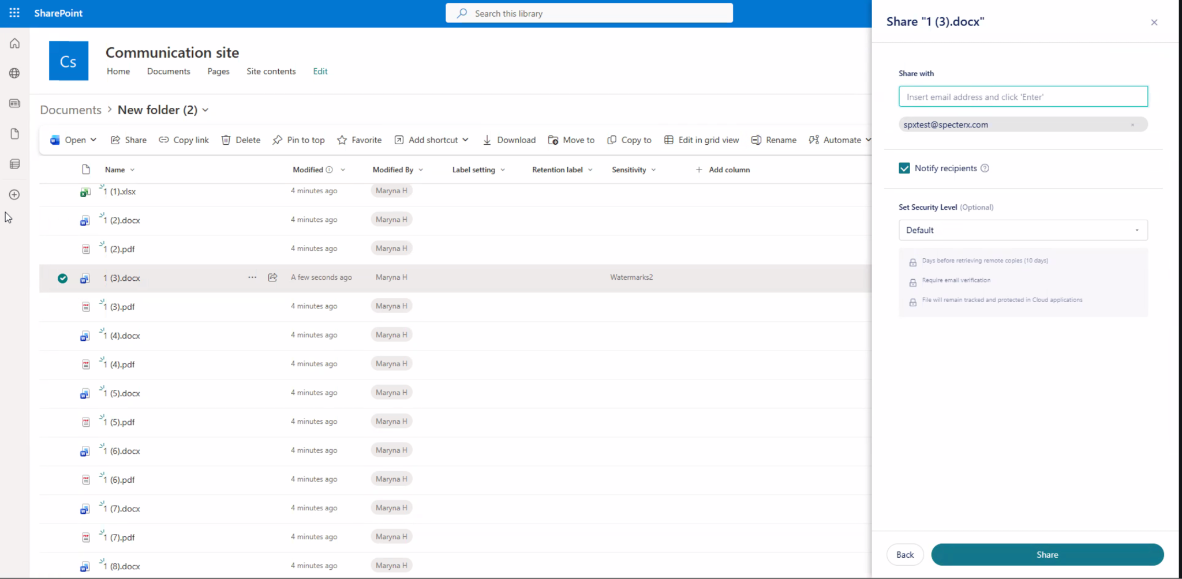
Within V1 GA release, the Share Drawer does not:
- Support real time share evaluation results via Platform Rules.
- Support Review of existing Recipients
- Message visibility or modification of existing permissions via the share drawer
- Message to senders that are resharing a file that they have previously shared via SpecterX that changes to policy will be applied to pre-existing active recipient access

3.8 Reference Indicators Published within Sharepoint Tenant
To indicate to users within the Governing organization’s sharepoint tenant that files are being used as an active reference within SpecterX, visual indicators are published directly in the Sharepoint Tenant File Library as displayed in this planned design:
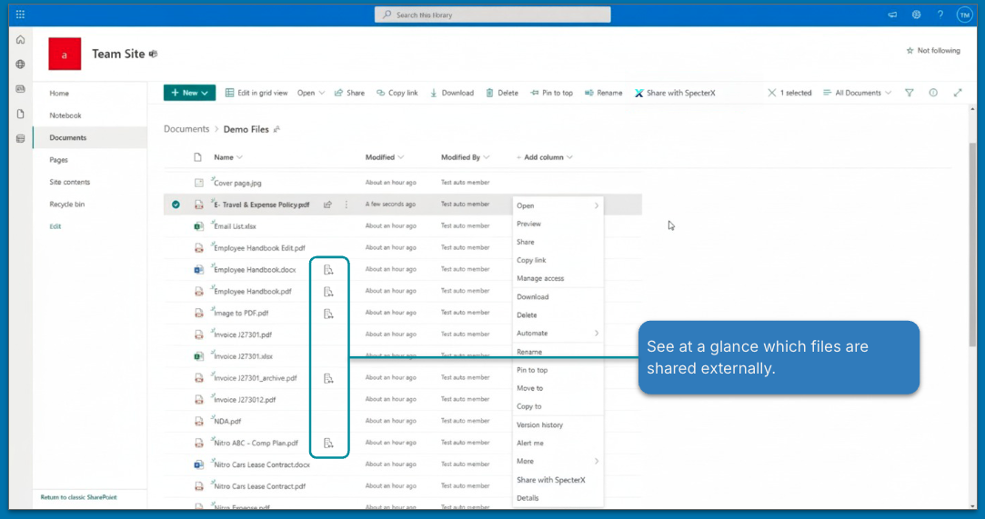
Technical flow is described in section 6.4 of this document.
Visual indicators publish whenever the SpecterX is holding an active reference file within the SpecterX platform across any licensed Collaborator.
- This reference appears visible to any user within the Sharepoint tenant.
- This indicator populates regardless of the status of the file’s provisioned recipient list (meaning this would publish regardless if the file is uploaded without recipients)
- This indicator does not provide additional information of the share status or data owners sharing the file.

4. Edge Cases – Concise Logic for Review

4.1 Reference File Deleted or Moved in SharePoint
This section defines the behavior when the SharePoint file that is serving as the SpecterX reference file is modified.Scenarios and Behavior
Behavior
SharePoint Event | Behavior/Outcome
File Renamed | File remains accessible to all recipients, though the filename in SpecterX metadata may be stale.
File Moved Within Same Drive/Site | File remains accessible to all recipients.
File Moved to Different Drive or Site | New access attempts fail with an error, as SpecterX is unable to retrieve the reference file from the new location. The SpecterX entry in My Files will be removed only upon access attempt. Failed retrievals are logged in Audit.
File Deleted (Soft Delete/Recycle Bin) | Access may still be possible during the soft-delete/Recycle Bin recovery period, as long as the file is recoverable in SharePoint.  New share attempts would be blocked/fail to create a new link due to the reference file state.
File Deleted (Hard Delete/Expiry) | New access attempts fail with an error. The file is no longer accessible. The SpecterX entry in My Files will be removed only upon access attempt. Failed retrievals are logged in Audit.

4.2 Multiple Collaborators Sharing the Same SharePoint File

The SpecterX SharePoint Connector treats each share action initiated by a different user as an independent governance record. This design ensures that one collaborator's actions do not affect the shares created by another.
Behavior
- Each collaborator has an independent:
  - My Files entry
  - Recipient list
  - Audit trail
- The Visual Indicator remains a simple binary indicator (dynamically fetched, not stored on the file):
“This file has been shared via SpecterX.”
(It does not indicate how many shares or by whom.)

4.3 Same User Shares the Same File Multiple Times
Behavior
- When sharing a single file, the share menu will contain the existing access list for this file.
- When selecting multiple files/folders, the share flow is treated as a new SpecterX share action with its own records.
- However, PARs will be calculated for each collaborator’s instance file with all the permissions applied to that instance.
Meaning: If a user shared a file with 2 people, and on a second share operation shared with a third person, the policy might change for all 3 users on the second sharing operation.
- The Visual Indicator does not reflect share count and is not duplicated.

4.4 SharePoint Permissions Change After a Share
Behavior (current assumption)
- If a user loses access to the file in SharePoint, they cannot initiate new SpecterX shares.
- Once the user doesn't have permissions to the file anymore, SpecterX won't be able to fetch files on his behalf, and recipients won’t be able to access these files.

4.5 Purview Classification Changes Over Time
This connector differs from standard document-upload flows, where labels are read once at ingestion.
- Purview label ingestion events via files shared from Sharepoint occurs when a new reference file is published per Collaborator and the label is not ingested again for future share events of that file by that Collaborator.
- If a Collaborator shared the file from sharepoint and prompted a new file reference associated with a different collaborator, this is considered a new ingestion event and the file is read again.
Because of this behavior, it is possible that the same file, owned by 2 different collaborators might hold different Purview labels records if changes were made with the file Purview label state within the Sharepoint tenant between file upload events between collaborators.

5. Limitations & Constraints

5.1 Mobile and Sync Clients
The SharePoint Connector (SPFx App) runs in modern web browsers (desktop and mobile).
It does NOT appear in:

- The native SharePoint mobile app (iOS/Android)
- The OneDrive sync client / File Explorer integration

Users accessing SharePoint via these methods will see the standard SharePoint interface without SpecterX controls or reference file indicators.

5.2 Customer Implemented Encrypted File Transformation Conflict with SpecterX - Purview Limitation Intersection
SpecterX cannot apply its own file-level protection or transformation to files that are already encrypted or protected by customer-configured Microsoft Purview policies within SharePoint.
This limitation occurs when a SharePoint tenant has applied Purview-based encryption or protection to files, including:
- IRM encryption
- Purview-applied watermarking
- Any Purview configuration that encrypts or restricts file access at the file level
Because these protections encrypt the file prior to SpecterX policy evaluation, SpecterX cannot apply additional file-level transformations such as:
- SpecterX IRM encryption
- SpecterX password protection
- SpecterX watermarking
- SpecterX Viewer-based access control
SpecterX cannot re-encrypt or modify files that are already encrypted by Purview.

Expected Behavior When This Conflict Occurs
If a Collaborator attempts to share a file with encryption prior to processing, the expected user facing behavior is…..
When SpecterX detects that a file is already protected by Purview encryption
- SpecterX can not apply additional SpecterX protection or transformation to the file
- SpecterX will still allow the file transfer or share to occur, if permitted by platform governance policy AND under a policy that does not require additional file transformation
- SpecterX will not govern recipient access through SpecterX-controlled enforcement mechanisms
- The file cannot be opened through the SpecterX Viewer
- SpecterX access tracking, watermarking, and enforcement controls will not be applied
Access enforcement remains governed by Microsoft Purview and the customer's native Microsoft protection configuration.
SpecterX will continue to audit the file transfer event but will not provide file-level governance enforcement.

5.3 Folder Sharing & Synced Changes are not Supported
The limitations surrounding folder behavior exist due to the scope of V1 that will be addressed in future versions.

As stated in the PRD overview, the Sharepoint V1 Connector does not support the sharing of folders and this naturally extends to file and folder sync behavior.

This is restated as a limitation as a flag for customer facing technical notes and internal Future Version records.

6. Technical Architecture & Implementation

6.1 High-Level Architecture
The SharePoint Connector operates on a Deferred Fetch model. Unlike standard uploads, the connector does not move file binaries into SpecterX storage at the time of sharing. Instead, it "seeds" authentication credentials to the SpecterX backend, allowing the platform to fetch the reference file directly from SharePoint only when a recipient attempts to access it.

Core Components
- SPFx Extension (Frontend): A SharePoint Framework client-side solution running in the user's browser. It handles UI integration (Context Menus, Visual Indicators), user interaction, and initial token acquisition.
- SharePoint Data Fetcher (SPDF / Middleware): A serverless backend service responsible for:
  - Token Storage: Securely storing and refreshing user OAuth tokens.
  - Graph API Proxy: executing operations against Microsoft Graph on behalf of the user (OBO).
- SpecterX Platform (Core): Manages policy, identity, and serves the protected content to recipients by requesting it from the SPDF.

6.2 Authentication & Token Management (The "Deferred Fetch" Mechanism)
To enable real-time fetching of files without user presence, the system utilizes the OAuth 2.0 On-Behalf-Of (OBO) flow with persistent token storage.

6.2.1 Token Seeding Flow
- Acquisition: When a user interacts with the Connector (e.g., opens the Share menu), the SPFx extension acquires a standard Graph API Access Token via the AadTokenProvider.
- Seeding: This token is immediately sent to the SPDF Backend (POST /auth/seed).
- Exchange & Storage:
  - SPDF exchanges this token with Azure AD for a Refresh Token (via offline_access scope).
  - Tokens are stored in a DynamoDB Token Store, indexed by the User's Tenant and Object ID.
  - These tokens are used for all subsequent background operations (Purview checks, content fetching).

6.2.2 Token Lifecycle
- Auto-Refresh: The SPDF automatically refreshes expired access tokens using the stored refresh token during any backend operation.
- Re-Authentication: If a refresh fails (e.g., password change, revoked consent), the API will return specific error codes distinguishing between "silent re-seed required" (e.g. token expired) and "interactive consent required" (e.g. consent revoked). In case consent is required, an email notification should be sent to the data owner, prompting them to re-authenticate. The email notification will lead to an interactive consent web page.

Update
Deferred fetching will be based on a service account use, fetching data on behalf of the data owners, instead of the aforementioned complex token management system.

6.3 Data Flow & File Lifecycle

6.3.1 Outbound Sharing (Metadata Only)
When a user shares a file:
- No Binary Upload: The file body is not uploaded.
- Metadata Onboarding: The SPFx extension calls POST /files/ext/onboard with specific file coordinates (siteId, driveId, itemId) and the current user's identity.
  - Folder Strategy: For Folder sharing, the connector sends the Folder's identity to the backend. The Backend is responsible for asynchronously enumerating the folder hierarchy via Microsoft Graph and registering the contained files as metadata-only records. This prevents frontend timeout issues with large folders.
- Registration: SpecterX creates a file record in "My Files" pointing to this SharePoint reference.
  - Multiple Owners: If multiple users share the same SharePoint file, SpecterX creates a distinct "file instance" record for each sharer. This ensures policy and audit trails are owned independently by each collaborator.

6.3.2 Recipient Access (Just-in-Time Fetch)
When a recipient clicks a SpecterX link:
- Request: SpecterX core requests the file content from SPDF.
- Context Resolution: The platform identifies the specific "file instance" being accessed (i.e., which User shared this specific link).
- Retrieval: SPDF retrieves the stored token specifically for that Owner.
- Fetch: SPDF calls Microsoft Graph API (/content) using that Owner's identity.
  - Latest Version Guarantee: To ensure recipients always see the most current content, the system fetches the file from SharePoint on every access request (or maintains an extremely short-lived cache, e.g., < 1 minute) rather than storing a long-term copy.
- Delivery: The file stream is piped through SpecterX protection logic and delivered to the recipient.

6.4 Visual Indicators (Visual Markers)
To indicate shared status without modifying SharePoint file metadata, the system uses a Read-Only API Check.
- Trigger: When a SharePoint Document Library view renders.
- Batching: The SPFx extension aggregates visible driveItemIds and debounces requests (e.g., 100ms window).
- API Call: Calls GET /files/onboard with the list of IDs.
  - Scope: The API returns true only if the current user has shared this file via SpecterX. If other users shared this file, but not the current one, no indicator should be shown.
- Rendering: If the API returns true for an item, the extension injects the SpecterX icon (Fluent UI BuildingSwapRegular) via a Field Customizer or DOM injection near the filename.
- Caching: Results are cached in the browser memory for the session duration to minimize API load.

6.5 Microsoft Purview Integration
Purview sensitivity labels are retrieved dynamically during the share flow to inform Policy Assignment Rules (PAR).
- Mechanism: The SPDF Backend queries the driveItem metadata via Graph API using the Owner's seeded token.
- Data Point: Specifically reads the sensitivityLabel or complianceTag property.
- Timing: Labels are read at the moment of the Share action. If labels change in SharePoint, the SpecterX policy updates only upon a re-share or re-evaluation event (as defined in Edge Cases).
- Fallback Strategy: If it is determined during implementation that Graph API does not reliably expose the Sensitivity Label (e.g. only available in CSOM/SharePoint Context), the implementation should instead support a fallback (or completely rely on this solution) where the SPFx Extension extracts the label from the page context at runtime and includes it in the POST /files/onboard payload.

6.6 Security & Permissions
The SPFx solution requires the following Microsoft Graph API scopes, granted via Tenant Admin Consent:
Scope | Purpose
User.Read | Identify the acting user.
Files.Read.All | Read file content and metadata (for sharing).
Sites.Read.All | Resolve site collection paths and IDs.
offline_access | Critical: Allows the backend to retain access via Refresh Tokens.
InformationProtectionPolicy.Read.All | Read Purview/MIP Sensitivity Labels.

6.7 Key API Interface Summary
(Internal Contract between SPFx and Backend)
- POST /auth/seed - Securely send the frontend token to the backend for OBO exchange.
- GET /files/onboard - Batch check if files are already shared (for Visual Indicators).
- POST /files/onboard - Register file metadata (Share action).
- GET /files/{id}/content - Internal endpoint for SpecterX core services to fetch binaries via SPDF.

7. Development Kit

SharePoint Testing Environment

User Login
SharePoint URL: https://specterxstagingms.sharepoint.com
Username:
user@specterxstagingms.onmicrosoft.com
Password:
RAtzRGkDMbphU26uL8ma.-nP-FW4RAN.ci


Admin Login
Admin URL: https://specterxstagingms-admin.sharepoint.com
SharePoint URL: https://specterxstagingms.sharepoint.com

Username:
system@specterxstagingms.onmicrosoft.com
Password:
NTYa.VhRRGoVjKME@Pn*@vNcEE.3JFYM7F


Installing / Updating the App
1. Make sure you have an App Catalog
- In SharePoint Admin Center → Active sites → Create → Other options → App Catalog.
- Or use the direct site if it already exists:
https://specterxstagingms.sharepoint.com/sites/appcatalog/SitePages/Home.aspx
2. Upload your app package
- Go to Manage App https://specterxstagingms.sharepoint.com/sites/appcatalog/_layouts/15/tenantAppCatalog.aspx/manageApps
- Upload your .sppkg file.
- When prompted, choose whether to deploy tenant-wide (“Make this solution available to all sites in the organization”).
3. Approve if needed
- If the app requests special API permissions (Graph, Teams, etc.), a Global admin must approve.
- Until approved, the app won’t be usable.
4. Add the app to a site (if not deployed tenant-wide)
- Go to the SharePoint site where you want the app.
- Gear icon → Site contents → + New → App → From Your Organization.
- Select the app and add it.
5. Use the App

- Go to a SharePoint site where you’ll test the App.
For us it ‘Marketing - Internal’ (click link to go there).
- Right-click a file.
- Click “Secure Share with SpecterX”
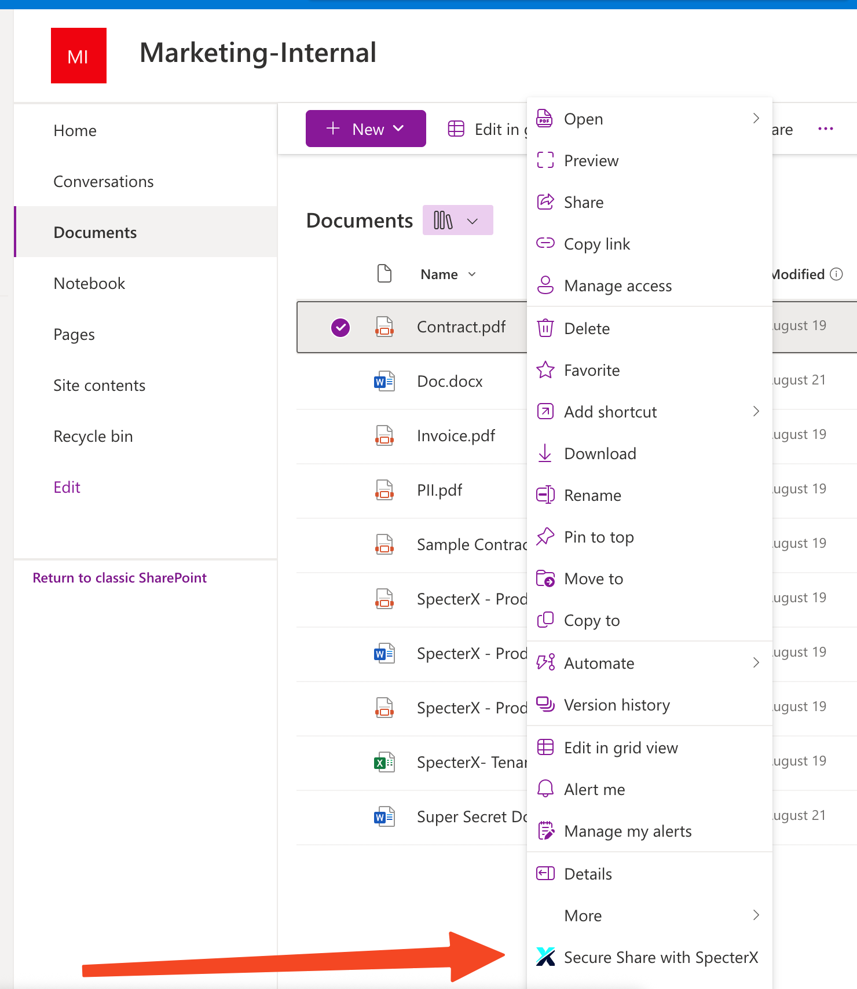

Repos
https://bitbucket.org/specterx/sharepoint-connector
https://bitbucket.org/specterx/sharepoint-data-fetcher

8. Audit Log Behavior

Sharepoint Connector Audit Behavior is aligned to Platform Governance Rules audit behavior and outlined in full in that PRD linked here. Behavior specific to Sharepoint is duplicated here:

Sharepoint Audit Events follow the established logic for this feature with V1 release. As Sharepoint V1 release applies backend Rule evaluation and action, Sharepoint Audit events for share events leverage established operations and evaluation patterns:

Upload Operation
Upload Operation is logged when the file onboard record is created when the Share drawer is open. This follows the persistent logic of the platform that an Upload operation is logged when the file record within the “My Files Library” is created, also specific to the Sharepoint Connector, it is the file meta data only that is uploaded at this time as this Connector is not leveraging dedicated storage and moving the file.

Recipient Added
Recipient Added Operation is logged consistent with V1 logic throughout this features, logging when the recipient has added recipients and selected to “share”. This distinguishes the share state sent for evaluation by Rules from the final share state provisioned with “Permissions Added”

Set Policy
Set Policy publishes only if the sender has changed the policy from the preselected default that was assigned and recorded with the Upload Event.

Backend Evaluation Operations
Operations for the evaluation and actions by PAR follow the existing logic established in this feature for backend evaluation:
- Share Request Evaluation populates for every share evaluated
- Rule Policy Triggered, Rule Block Triggered, and Rule Exception Triggered populate only when triggered.

Permissions Added
As per consistent logic of this feature, Permission Added Operation reflects the final shared state post evaluation.

